

A Project Report On


Crime Bureau Management System

Submitted by

Mr. gole sumit Suresh
Mr. Gunjal bhushan harishchandra

Under The Guidance Of

Prof.Dhage H.Y.

Department of bba [comp. Application]
Tal- Sangamner-422 605 Dist- Ahmednagar
Academic YEAR 2017 -2018
Semister vi

S.M.B.S.T.COLLEGE SANGAMNER

This is certify that
Mr. Gole Sumit Suresh
Mr. Gunjal bhushan harishchandra

Has Successfully Complete Their Project Work

On
Crime Bureau Mgt System

In Partial Fulfillments of the BBA[C.A.]

SAVITRIBAI PHULE PUNE UNIVERSITY
For the academic year
2017-2018

Prof. Dhage H.Y. Prof. Kashid P. R. Prof. Nawale S.D.
(Project Guide) (Head of Department) (Vice-Principal)

Internal Examiner External Examiner



SAHAKAR MAHARSHI BHAUSAHEB SANTUJI THORAT

ARTS, SCIENCE AND COMMERCE COLLEGE SANGAMNER”
TAL. SANGAMNER-422 605 DIST. AHMEDNAGAR
2017-2018

The Student of Final Year Course “Bachelor of Business Administration[C.A.] ” Humbly Submitted that We have Completed from Time to Time Project Work as Described in the Report by our own Skill and Study between the December to March Months as per Guidance of Prof. Dhage H.Y.

Date: / / 2018
Name of Students: Signature of Students

Mr. Gole Sumit Suresh
Mr. Gunjal Bhushan Harishchandra

ACKNOWLEDGEMENT

It gives us great pleasure to present our project report on “Crime Bureau Management System” for Police Station. As per requirement of curriculum of the course BBA [COMPUTER APPLICATION] from the Savitribai Phule Pune University at the S.M.B.S.T. college.
First we heartly thankful to project conductor and guide Prof. Tambe D. for selecting this project and for his guidance and encouragement at every step in our way completing this project.
We would also like to thanks Mr. Sachin Varpe sir, Prof. Dhage Sir and Prof. Kashid sir H.O.D. of B.B.A.[C.A.] department of our college for giving us important guidance during Project.
Lastly we would like to thanks all the staff members of BBA [COMPUTER APPLICATION] Dept of S.M.B.S.T. College Sangamner for their help to provide information to complete this project.
We are grateful to my all friends who gave the valuable suggestion for development and designing of the system.

INDEX

Sr.No. | Topics | Page No.
 | INTRODUCTION | 6
 | Problem Definition  - Existing System  - Objectives And Goals System | 7
 | Hardware And Software Requirements | 9
 | Requirement Analysis & Feasibility Study | 10
5. | System Design  - ER Diagram  - Data Flow Diagram  - UML Diagram | 12  13  14  18
6. | Data Dictionary | 25
7. | Screen Shots  - Sample Screen | 28
8. | Future Enhancements | 36
9. | Conclusion | 37
10. | Bibliography | 38

INTRODUCTION

In this Project we are describing the Computerized system for “Crime Bureau”. We had studied this system with respect to the criminal record. The “Crime Bureau Management System” is use to manage the criminal record and create the systematic presentation of the data into the system. It helps to generate the report of the criminal including all the necessary information about the criminal. Which help to reduce the paper work and to avoid the misuse of the data. The system provide all the computerize process which include all the operation.
The system has various modules that can describe the whole process which carried out in the criminal investigation process. This System provides feature of searching and tress the appropriate record. The searching module help to find any criminal record entry previously done or not using only name of person. If ones the record has successfully saved in the system can be access any number of time for the further investigation. It is helpful to decrease the effort of maintaining the record in the file.

PROBLEM DEFINATION

Whenever the Crime happen it is difficult to store all the necessary information related to Crime. Now days no. of crimes are frequently happen in city it is difficult to store all the information related to Criminal. Our system are design to store all the information about the crime & criminal. The Systematic data has been preserved, the data can access any no. of time.

Existing System :-

In the existing previous system the information are store in the register or return by hand. This drawback is overcome in our system.

Objectives and Goals :-

Assurance of No Misuses.

Provide Reliability.

Easy to Access.

Data Security.
- Easy to Use.

SCOPE OF THE SYSTEM:-

- This project is for maintaining the database which compose of the reports , documents and analysis.
- This system contains the each process from the beginning also it is very time saving.
- The proposed system invented to make working environment and simpler method.
- It helps in solving all the hurdles and difficulties currently faced by police.
- This proposed system is completely user friendly and else better to access.
- There is no loss of information as all of stored in secured data base.
7. Reduction of paper work is accomplish.

HARDWARE AND SOFTWARE REQUIREMENTS

- SOFTWARE REQUIREMENTS:-

Software: - Microsoft Visual Studio 2008.
Backend: - SQL Server.

- HARDWARE REQUIREMENT:-

Minimum RAM:-512 MB
Hard Disk:-80 GB
Processor:-Intel Pentium, CORE i3, CORE i5
Operating System:-Windows 7

REQUIREMENT ANALYSIS

Requirement analysis means identification & understanding & critically examines the system & its subsystem for purpose of achieving objectives for the system. The basic objectives of system analysis are to understand & modify the system in some way to improve the functioning.

1 . Details of Criminal and their type of Act .

2 . On one button click generate FIR Report & Criminal Report.

The above information can be given to a high extend using the proposed project.

FEASIBILITY STUDY

The feasibility study is a process of evaluating and deciding whether the proposed system is feasible or not.
The feasibility study is carried out in the following aspects:-
1. Technical feasibility
2. Operational feasibility
3. Economical feasibility
4. System Analysis

Technical Feasibility:
The technical requirements of the system are Visual Basic Studio 2008 with Microsoft SQL server support. All the form now a day has this apability. Thus the Technical requirement of the project can be easily satisfied.

Operational Feasibility:
The system is very efficient for the organization. It saves their precious time and also the information can be accessed according to their convenience.

Economical Feasibility:
All the necessary hardware and software required for this system is easily available. No additional software or hardware is required. This system offers the following benefits:
- Reduced paper work
- Less chances of errors
- Easy of accessibility.

- System Analysis: -
This phase is detail appraisal of the existing system. This appraisal includes how the system work & what it does. It also includes finding out in more details about what the system problems are, and what user requires from new system or any new change in system. After this phase analyst should be familiar with both the detail operation of the system & what is required by the new system.
The output of this phase results the detail model of the system. The model describes the system function, data 7 system information flow. The phase also contain the detail set of user requirement & these requirements are used to set objective for the new system

SYSTEM DESIGN

After the analysis it must be clear what must be done. In system design, we plan how to do it. The objectives of the system design are to decide in general how the system should be implemented. Individual physical components, Program files, documents, will be identified. During the analysis we prepare a blue print for the system.

Actually, the system design is the process of planning a new business system or one to replace or complement an existing system. Analysis what the system should do and design specifies how to do and design specifies how to accomplish the objectives. System design begins with a search for alternative solution.

The design of an information system produces the details that state how a system will meet the requirements identified during system analysis. This process is known as the logical design and the process of development program software is referred to as physical design.

The design process begins by identifying reports and other outputs the system will produce. The system design also describes the data input, calculated or stored. The produces written tell how to process the data and produce the output.

*UML Diagrams*
ENTITY RELATIONSHIP
DIAGRAM
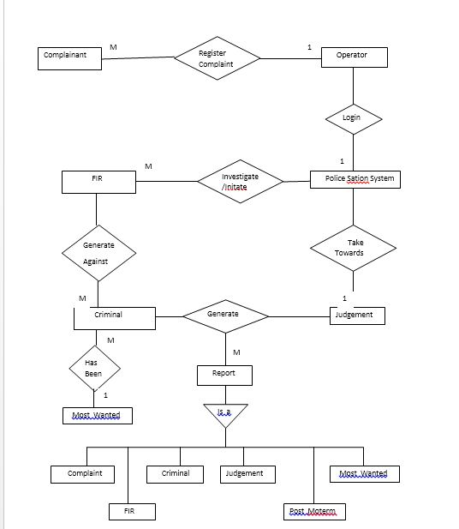

- Use Case Diagram:-

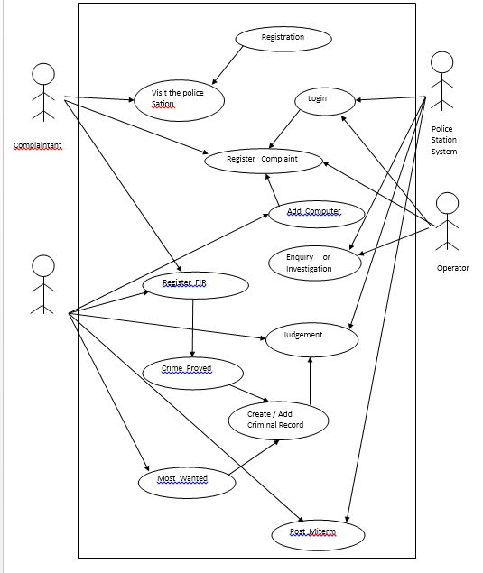

2) CLASS DIAGRAM:-

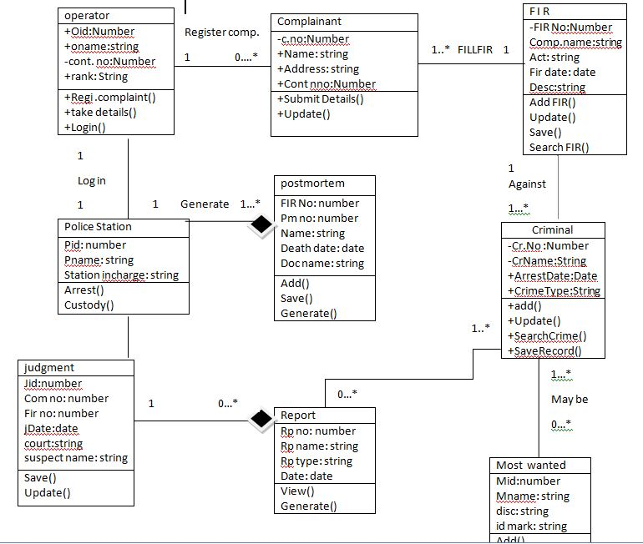

4) SEQUENCE DIAGRAM:-
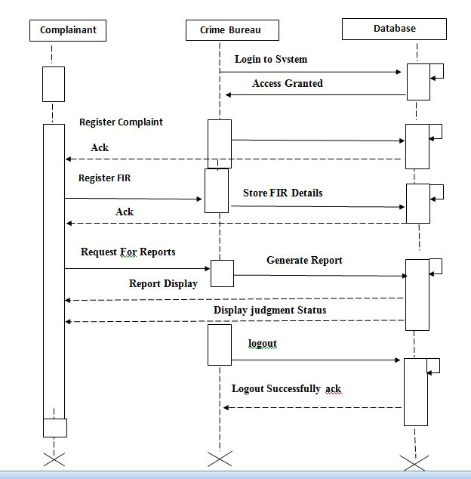

5) ACTIVITY DIAGRAM:-
Complainant
System
Database
Visit Bureau
Display Home
Admin Login
Verify Login
Add FIR,Criminal
Forward to Judgement
Display Reports
Logout

6) STATE CHART DIAGRAM:

Registration
Admin Login
Create FIR , Register complaint ,Add Criminal

Investigate/ judgement

Display/Generate Reports
No
Yes
Validate

7) COMPONENT DIAGRAM:-

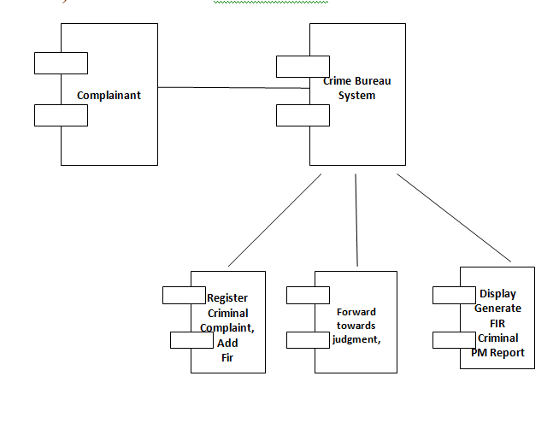

7) Object Diagram:-

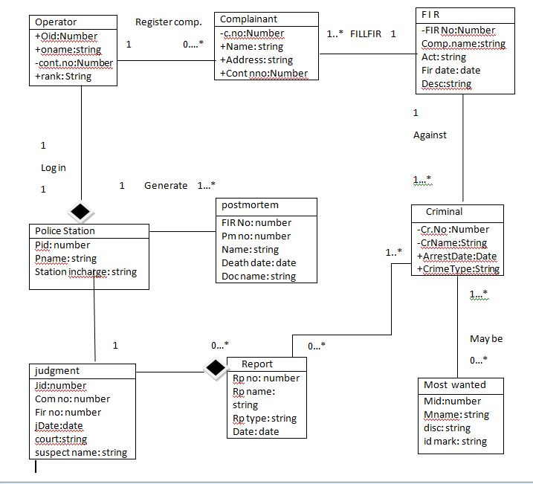

8) Collaboration Diagram:

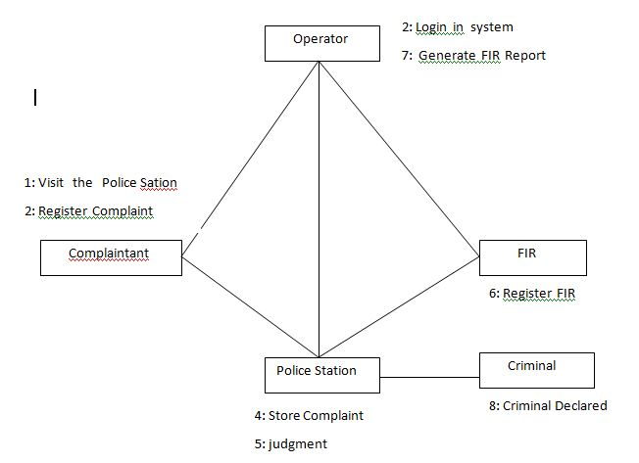

DATA DICTIONARY:-

Complaint Register :

Fields | Data Type | Description
Complaint No. | Int | Allocated Case No.
Name_of_Criminal | Varchar(20) | The Suspected Person
District | Varchar(20) | Place of Incident
Date_of_Case_Regi. | Date | Date of Registration
Police Station | Varchar(20) | Name of Police Station
Name_of_Complainant | Varchar(20) | Person Register Complaint
Cont_No. | BigInt | Contact Number
Name_of_Witness | Varchar(20) | Present at Place
Description | Varchar(20) | Description of Case

FIR Registration :

Fields | Data Type | Description
FIR No. | Int | Allocated FIR No.
Name_of_Criminal | Varchar(20) | The Suspected Person
Nationality | Varchar(20) | Nationality of Criminal
Date_of_FIR_Regi. | Date | Date of FIR Regi.
Act | Varchar(20) | Type of Crime
Action Taken | Varchar(20) | Action Against Criminal
Place_of_Incedent | Varchar(20) | Spot of Act
Name_of_Informer | Varchar(20) | Person Who Inform ?

Criminal Registration :

Fields | Data Type | Description
CR_No | Int | Register Criminal No.
Name_of_Criminal | Varchar(20) | Criminal Name
Date_of_Arrest | Date | Date of Arrest Criminal
Act | Varchar(20) | Type of Crime
Action_Against_Criminal | Varchar(20) | Action Perform on Crime
Most Wanted | Varchar(20) | Check Criminal MW or Not
Criminal Photo | Memo | Criminal Image

Judgment Record :-

Fields | Data Type | Description
JdNo. | Int | Register Criminal No.
Complaint No. | Int | Registered Complaint No.
FIR No. | Int | Registered FIR No.
Court | Varchar(20) | Name of Court
Judge | Varchar(20) | Name of Judge in Court
Suspect Name | Varchar(20) | Doubtful Person
Report | Varchar(20) | Result Against Criminal
Jd_Given | Varchar(20) | Name of who gives the jd
Jd_Date | Date | Date of Judgment

MostWanted Record :-

Fields | Data Type | Description
Mw No. | Int | Register Most wanted No.
Mw Name | Int | Name of Most wanted Person
Age | Int | Age of Mw Person
Sex | Varchar(20) | He/She Person
Description | Varchar(20) | Description of Case
Identification Mark | Varchar(20) | Mark of Person to identify
Photo | Memo | Photo of Mw Person

Postmortem Record :-

Fields | Data Type | Description
PNo. | Int | Register Postmortem No.
FIR No. | Int | Register FIR No.
Name | Varchar(20) | Name of Person
Death Date | Date | Date of Person Death
Case Description | Varchar(20) | Description of Case
Doctor Name | Varchar(20) | Name of Doctor who Handle Operation
Hospital | Varchar(20) | Name of Hospital
Police Station | Varchar(20) | Police Station Name
Result | Varchar(20) | Result of Postmortem
ScreenShots :-
Login Page:

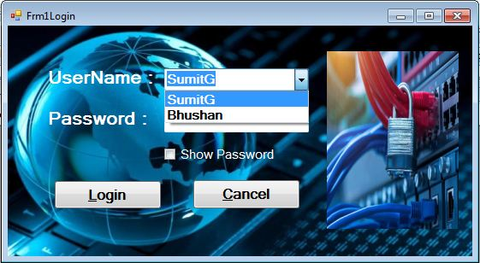

HomePage:

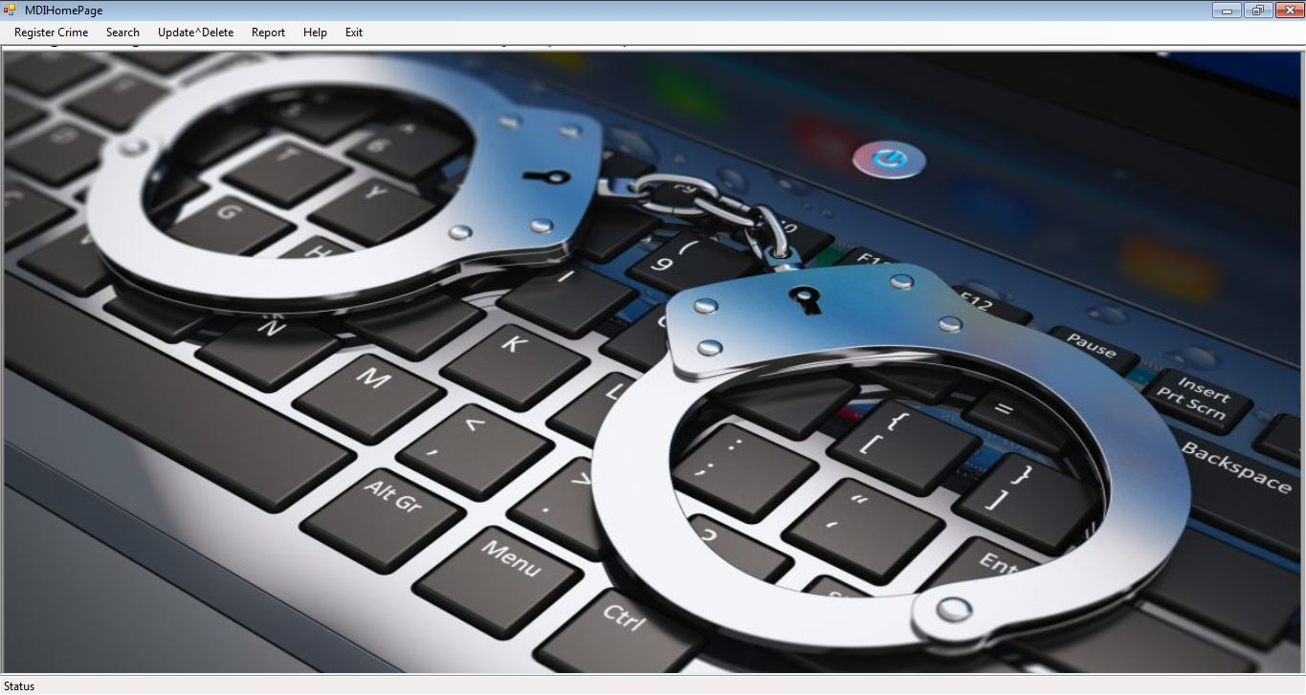

Complaint Form:

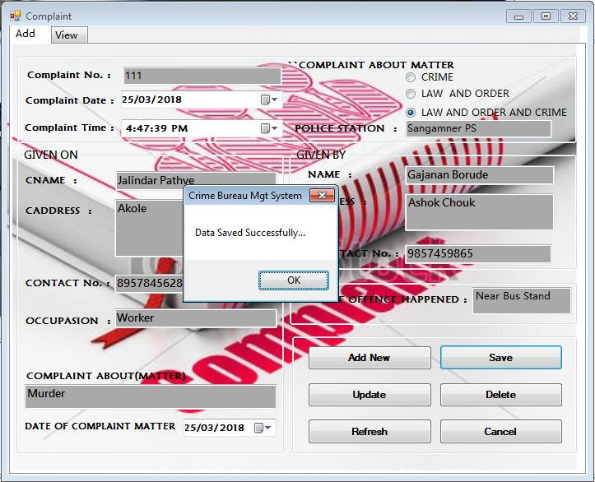

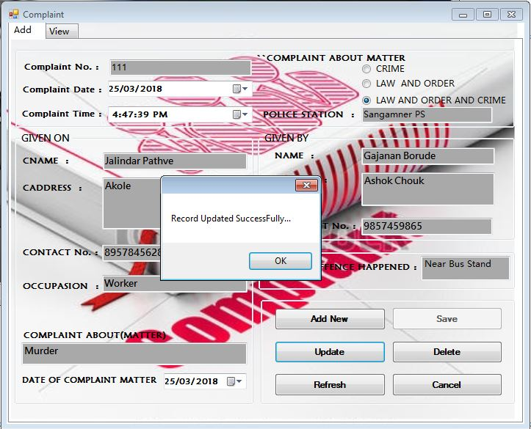
FIR Form:

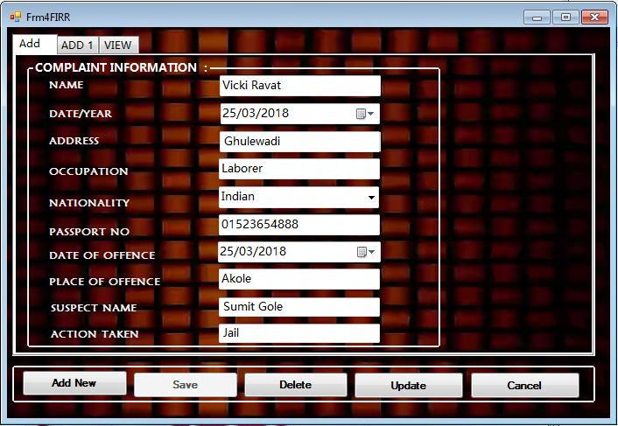

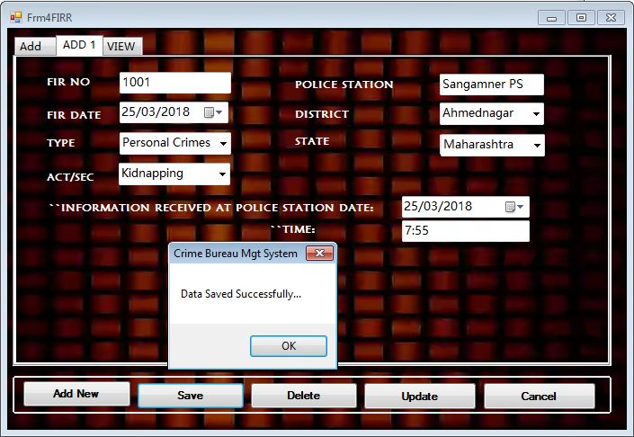
Criminal Form:

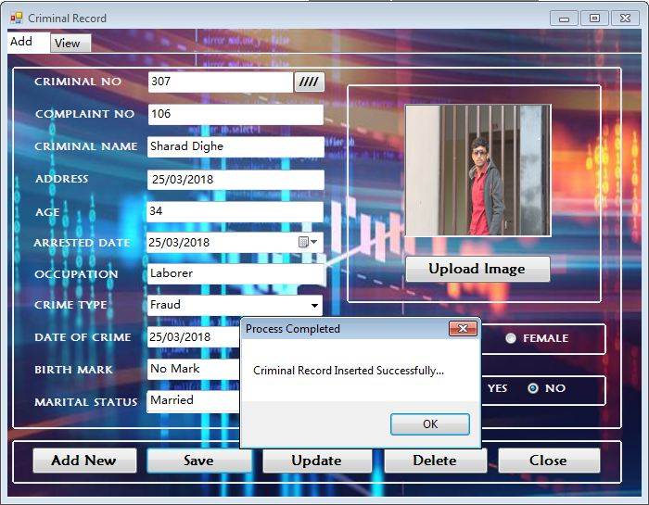

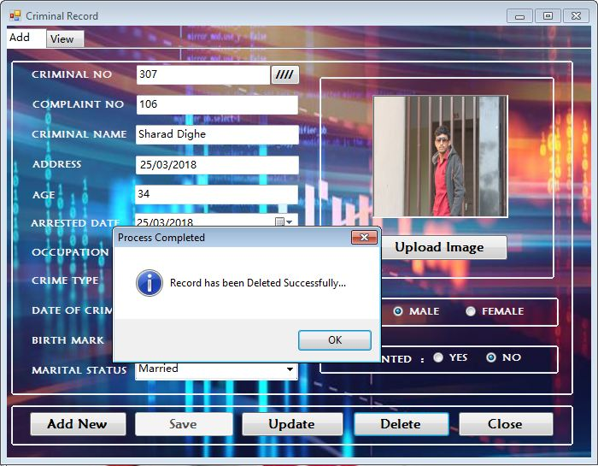

Judgment Form:

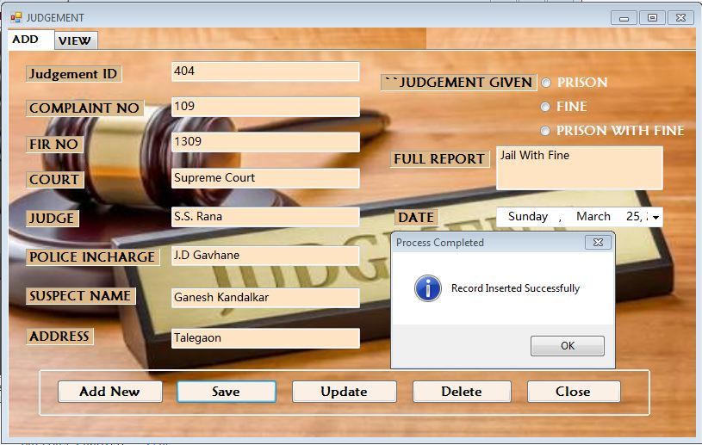

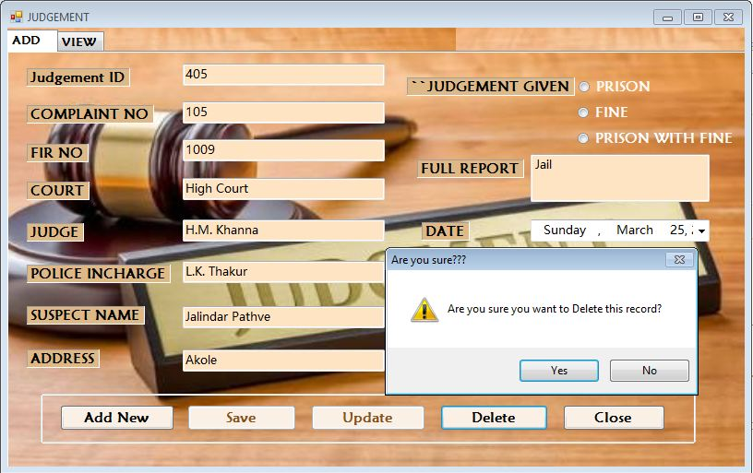
Most Wanted:

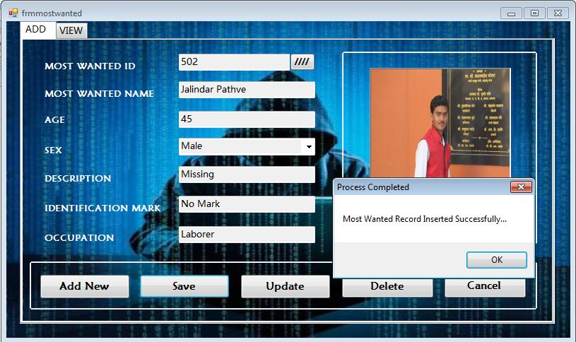

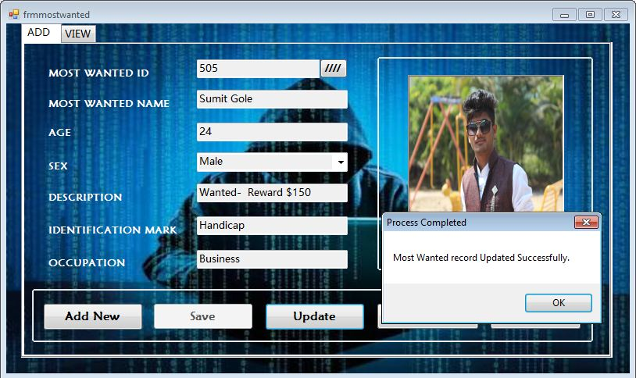
Postmortem:

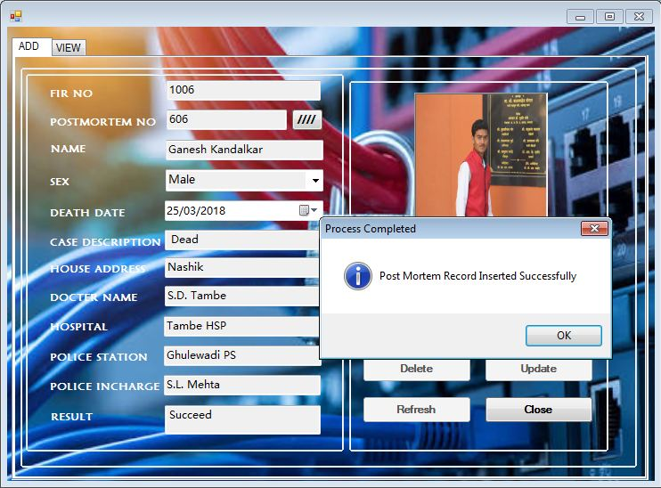

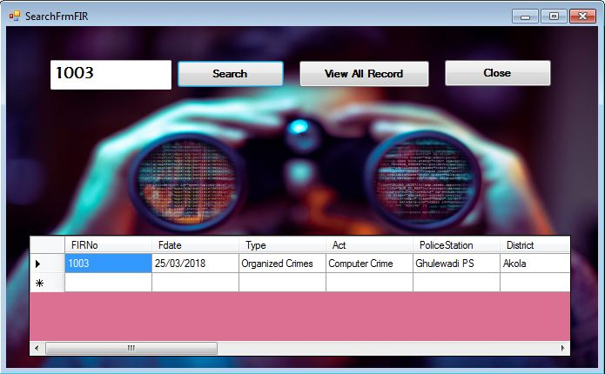

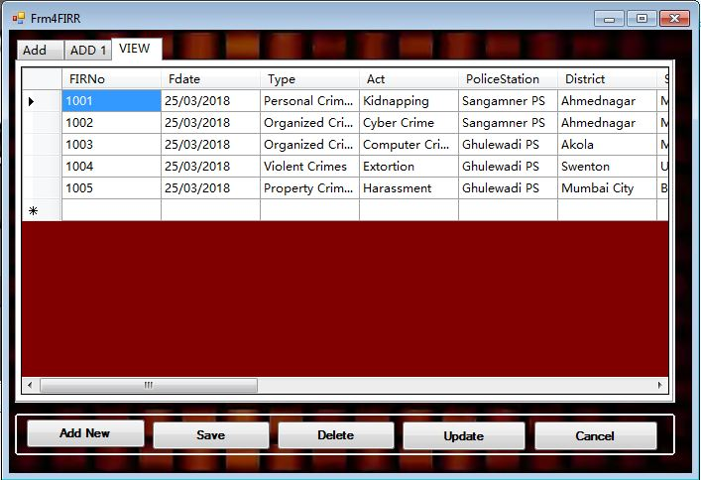

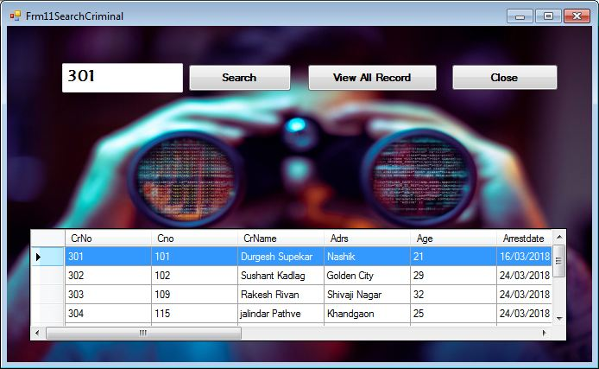

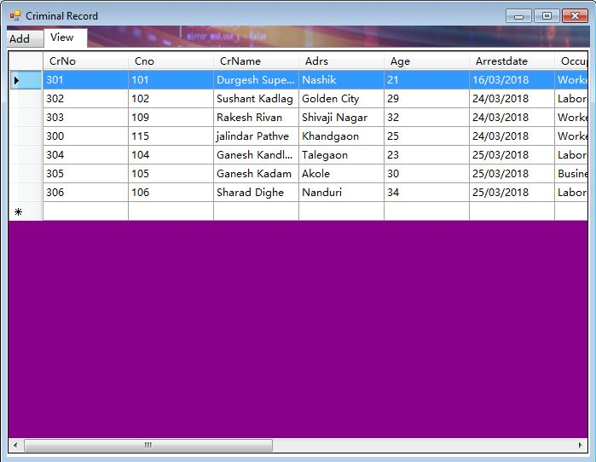
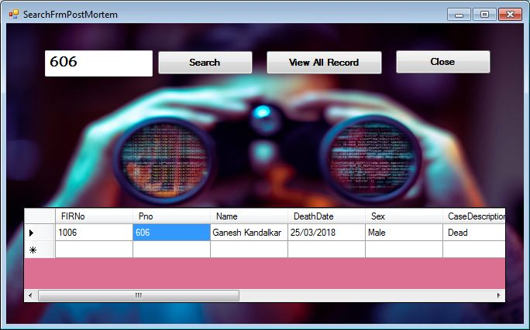

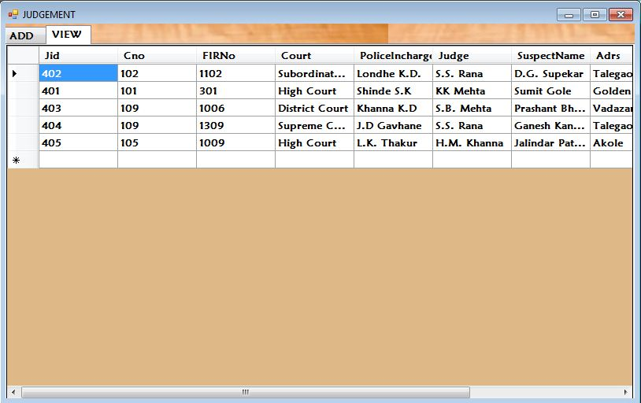

Reports :-

Complaint Report:

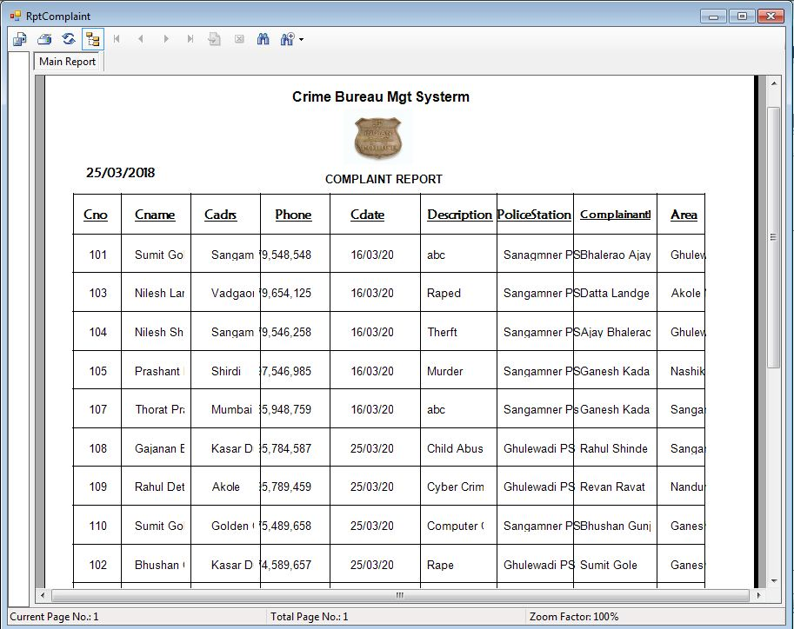

FIR Report:

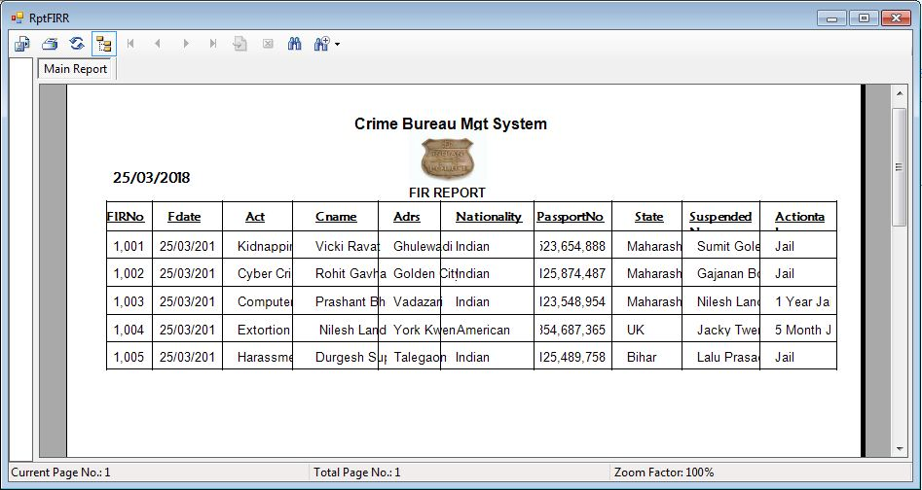

Judgment Report:

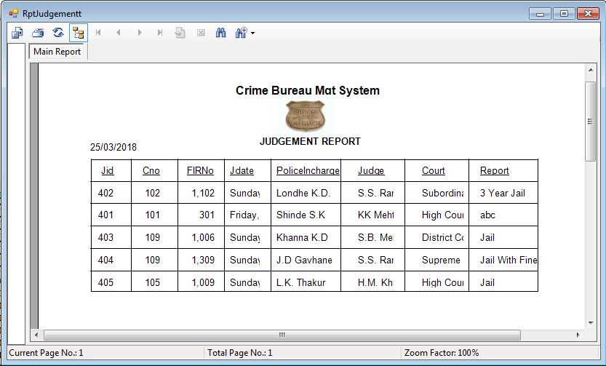

Most wanted Report:

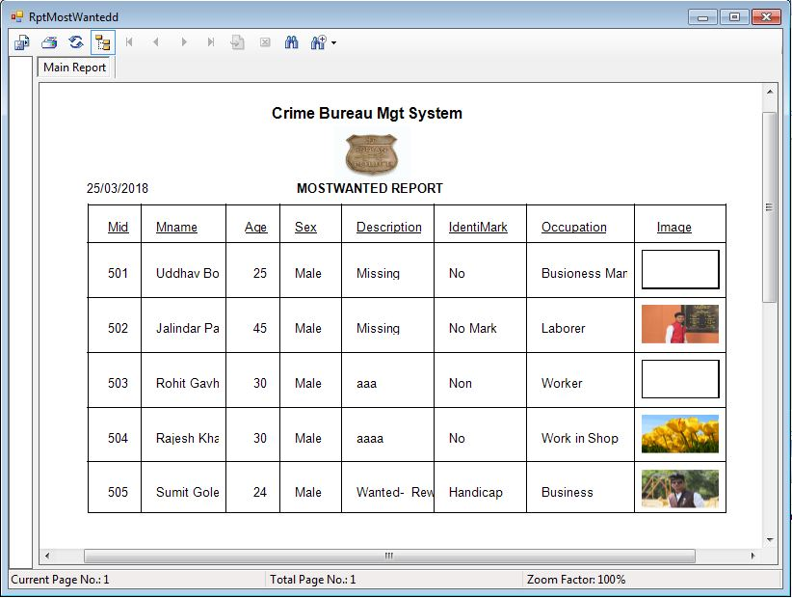

Future Enhancements:

- We have developed the system fully online in future.

- In future people can online register complaint.

- The FingerPrint Scan, Face Detection Technology increase the project functionality

- We have developed help to some extent you can increase it.

- We used some menus but you can increase no. of menus for good usability.

- We have to develop this System as online for further use.

- We are also trying to make this system to keep record of Criminal as Act wise.

CONCLUSION

Definitely we try our best to make a system that is unique, distinct, adequate, and a versatile. We think we have been successful for that to a greater extent, because our system has given us many satisfactory results at the time of its testing itself, so we are much confident after it’s final completion.

We conclude that the software developed by us will be a much satisfying system if actually implemented in Colleges.

We would be gratified to take the incite of the person referring to the concept of this project and thereby helping us to enhance our project.

BIBLIOGRAPHY

Books used as a reference to provide the guidelines for analyzing, documenting and designing our Project Attendance Analysis:

The Complete Reference Book of VB.NET

By - Jeffrey R. Shapiro

Object Oriented Software Engineering

By - Roger Pressmen

Visited websites:-

http://www.guideproject.com

http://www.ebooks.com

http://www.youtube.com

http://www.tutorialspoint.com

Thank You……..!

